
Business Name: NICHOLE LASHES & BEAUTY
Address: 1578 Highland Drive, Mackenzie, TN 38201
Phone Number: 731-358-5825
Owner: Angle Nerobill

Table of Contents
EXECUTIVE SUMMARY 3
VISION/ MISSION 5
Company Overview…………………………………………………………………………….6
PRODUCT/ SERVICE STRATEGY………………………………………………………….8
MARKET ANALYSIS …………………………………………………………………………9
MARKETING PLAN ………………………………………………………………………….9
FINANCIAL PLAN…………………………………………………………………………….10
SUPPORTING DOCUMENT ……………………………………………………………….12

EXECUTIVE SUMMARY
Highland Drive in Mackenzie City, Tennessee is in need of a salon spa that can offer quality massages, facials, hair styling, and other health care services at competitive prices. The largest percentage of beauty and spa businesses do not cater for men and people with low income. Therefore, it is important to have a business that can cater for the needs of people from all demographics. All populations in Mackenzie city should be able to enjoy health benefits, relax, and have their beauty enhanced.
To address this challenge, Nichole Lashes & Beauty was founded. Nichole Lashes & Beauty is a business that was developed with the objectives of improving beauty, health, and relaxation through personal treatments. The business is located in 1578 Highland Drive, Mackenzie, TN 38201.to make appointments, suggestions, or raise concerns, potential clients can contact the company through 731-358-5825. This is an excellent location considering that that there is plenty of natural resources. The presence of resources, cheap land rates, and favorable municipal taxes attract a large number of residents, which in turn, increases the number of potential customers. Rapid industrial development and large percentage of educated people indicate that the residents earn a higher average household income. Highland Drive has attracted a large number of retail businesses, thus becoming a hot urban center.
It is a spa and salon business that will offer a variety of services and products to heal the body physically and mentally. The salon business will be designed to offer hair styling services to both men and women. On the other hand, the spa will be designed to offer energy works, body works, and massages. The business will be set in a serene environment that will enhance relaxation and healing.
The success of the company is linked to an excellent location, provision of diverse, affordable and quality services, and having a customer centered focus. Since it was founded, Nichole Lashes & Beauty has continued to provide customers with dependable and quality services, which are achieved by the well-trained team. The company has an intensive and comprehensive training program, where employees are trained on how to provide quality and competent customer services. Another main focus of the company is to provide customers with services that address their needs and interests beyond their expectations. Employees are motivated with incentives, promotions, and holidays to improve their performances. Taking this approach guarantees the company high consumer returns. Also, it is an approach designed to help the company achieve competitive advantages over its competitors.
Nichole Lashes & Beauty will use different sales and marketing strategies to help promote its position in the industry. These strategies will be achieved by conducting a comprehensive research of the target population, the competition, distribution, supply chain, promotion, positioning, customer services, and financing. The sales strategies, which will be used are discussed as follows. Knowing the products will be essential because it offers an opportunity to understand the positive and negative effects of the products. Knowing the target customers is crucial because the company will have information on their consumption behaviors and ways to retain them. Making the benefits of seeking services and products known to customers will be used to attract customers. Communication, listening to customer needs, have follow-ups, solve solution and provide feedback will be excellent sales strategies. The marketing strategies used to market the business are using social media, the internet, and email marketing. A combination of these platforms will be necessary to make the brand known.
The owner and CEO of the business is Angle Nerobill. As a startup business, there are few management positions in the company. The company has 14 employees, including the general manager and assistant manager. The manager and the assistant will be active therapists and stylists, to ensure that all potential is tapped. The manager will be required to plan, organize, lead, and control employees in the salon and spa sections. There will be 9 employees in the salon section with room for future expansion. After expansion, the section will be able to accommodate up to fifteen employees. Out of the nine employees, two will be receptionists and the others stylists. The spa section will have five employees, two massage therapists, an energy therapist, a nail specialist, and a receptionist. Each section will have a supervisor who will oversee operations and employee performance in the case the manager and or the assistant manager is absent.
Nichole Lashes & Beauty has forecasted sales for three years. The forecasts show that the business will be making substantial profits by the third year in business. The business will acquire funds from the savings of the owner and additional funds from fundraisings. As an existing business, Nichole Lashes & Beauty seeks to offer unique services that are not offered by the competition. Sales are expected to increase by 2.22% and a 2.66% increase in the gross margin.
VISION/ MISSION
The mission statement of the business is to create an environment for people to express and explore their styles by providing top quality services and products, which improve beauty, health, and relaxation for communities in Mackenzie city and beyond. The business will be designed to help people reconnect their lives with their true purpose through hair styling, body and energy works and massages. Nichole Lashes & Beauty seeks to establish itself as a destination for people to escape from the daily hustles of life, where they can boost their energies, and improve physical and mental wellness.
The goals of the company is to become the best beauty salon and spa in Mackenzie city and Tennessee. Another goal is to offer services to all populations in the community and beyond. The company aims at having healthy profits before taxes by the third year of business.
The objectives of the company are outlined below.
- Become a well-established business in the community
- Have over 90% consumer return rate
- Have a healthy profit before taxes
- Have high sales revenues by the end of the third year of business.
The goal and objectives of the company will be achieved by hiring skilled and diverse employees who are enthusiastic and dedicated to succeed. Establishment of trust between the company and the community will be necessary because it will guarantee residents quality services and products, which satisfy their needs. The easily accessible location, affordable prices, and effective sales and marketing strategies will play a key role towards the achievement of organizational goals and objectives.
The vision of Nichole Lashes & Beauty is to bring inspiration, create better lifestyles for many people, and improve the physical and mental wellbeing of diverse populations.
COMPANY OVERVIEW
Nichole Lashes & Beauty is a new business that seeks to offer customers with unique services in hair styling, body and energy works, training and sports and massages in a serene and relaxing environment. It is a destination where people can rejuvenate their lives by enjoying services like therapeutic massages, facials, reiki, sauna, manicure, pedicure, hair styling, therapeutic touch, and products that enhance beauty and health.
The company is privately owned by Angel Nerobill. The management of the company is crafted based on respect of customers, leaders, and fellow employees. The establishment of an effective workspace where love and passion are cultivated helps towards the achievement of over 90% customer return rate. The management team comprises of the owner of the business, a manager and an assistant manager.
The starting number of employees will be fourteen including the manager and assistant manager. 9 employees, including the manager will work in the salon section while 5 employees, including the assistant manager will work in the spa section. The salon will have two receptionists while the spa will have one receptionist.
The management team is outlined below.
- Angel Nerobill – owner, founder and CEO of Nichole Lashes & Beauty. He has a degree in psychology from the University of Mount Zion. He has been a manager in the retail sector for ten years.
- Alex Robinson – is the CFO of the firm. He retired after 30 years as the CFO in Chicago hospital. Alex hold a PhD in business administration.
- Karen Jennings – general manager. Is a top designer and hair stylist for the last two decades. She is a reiki master usui shiki ryoho for five years.
- Edward Brandon – Assistant manager. Has nine years’ experience as a hair stylist.
The salaries (for three years) of the management and employees are shown in table 1 below.
Table 1: Employee salaries
personnel | year 1 salary ($) | year 2 salary ($) | year 3 salary ($)
CEO | 62,000 | 62,000 | 62,000
CFO | 60,015 | 60,015 | 60,015
general Manager | 59,063 | 59,063 | 59,063
Assistant Manager | 43,000 | 43,000 | 43,000
100% Commissioned Employees | 150 | 160 | 160
Receptionist | 17,050 | 17,0150 | 17,050
No. of Employees | 16 | 16 | 16
Total Annual Payroll | 241,278 | 241,288 | 241,288

PRODUCT/ SERVICE STRATEGY
Nichole Lashes & Beauty will offer a broad range of products and services to both men and women. The company will offer beautifying, rejuvenating, and relaxational services and products with a comprehensive explanation of benefits and usages.
In the salon section, the average cost for styling women will be $40 and $35 for men. Application of perm will cost $90, hair color ($80), wax ($50), and $140 for a combination of the services for women and $135 for men. Products in this section include mirrors, make-up kits, shampoos, hair and nail conditioners, cleansers, and brushes. In the spa section, services will be divided into two categories, i.e., energy works and body works. Services in the energy works include reiki, energy revitalization, and therapeutic touch. Services in the body works will include massage, manicures, pedicures, waxing and aromatherapy.
In the future, the company will offer healing touch, to improve the current relaxational techniques.
MARKET ANALYSIS
The population of Mackenzie city in 2018 was 5363 people with a median age of 41.2 years. The median household income has decreased from $35600 to $33304. The poverty rate in the area is 24.2%. Whites account for 85%, blacks 12.6%, Hispanic 1.38%, and Asian 0.26%.
Nichole Lashes & Beauty will focus on offering services to both men and women. The level of competition in the area is limited considering that it is still under development. Competition will be faced from Rejuvenate MedSpa & Salon, Cut Above, and Salon Serendipty. The location of the property is not exposed to environmental risks because it is easily accessible, not crowded, and allows for easy navigation.
MARKETING PLAN
The marketing strategy will focus on taking advantage of the convenience of the location and emphasize the brand name through comprehensive advertisement. Also, the company will be marketed by building relationships with the community through provision of quality and dependable services. The brand name will be sold by showcasing the skills of the employees, their use of etiquette, courtesy, passion, and trust to create a memorable and fulfilling experience.
The company will be advertised through local newspapers, radio stations, mail outs to households within a 3-mile radius, and in the local TV channels. Social media platforms, including Twitter, Facebook, Instagram, and YouTube will be used. The company will design a website where target customers can log in.
Public relations will be achieved by interacting with other businesses in the community. These mutual relationships with other businesses will help improve the company’s visibility to potential clients.
FINANCIAL PLAN
Start-up funding
Start-up expenses to fund - $95,000
Start-up assets - $69,000
Total funding = $164,000
Sales forecast
sales | year 1 ($) | year 2 ($) | year 3 ($)
salon section revenues | 750,000 | 1,200,047 | 1,350,700
spa section revenue | 200,098 | 350,000 | 548,000
Total sales | 950,098 | 1,550,047 | 1,898,700
Direct cost of sales | year 1 ($) | year 2 ($) | year 3 ($)
salon section | 500,750 | 759,400 | 820,900
spa section | 198,650 | 230,340 | 270,760
total | 699400 | 989740 | 1091660

Expenses
Legal - $4000
Stationary - $2500
Brochures - $3000
Construction design - $30,100
Insurance - $3200
Rent - $20,000
Equipment - $15,100
Others - $17,100
Total expenses = $95,000
Balance sheet
current assets | year 1 ($) | year 2 ($) | year 3 ($)
cash | 85,600 | 410,300 | 820,200
inventory | 55,800 | 109,300 | 120,340
total current assets | 141,400 | 519600 | 940540
fixed assets | 0 | 0 | 0
total fixed assets | 0 | 0 | 0
Total assets | 141400 | 519600 | 940540
Liabilities & owners equity
current liabilities
accounts payable | 63416 | 108715 | 119876
current borrowing | 0 | 0 | 0
total current liabilities | 63416 | 108715 | 119876
Total capital | 85,716 | 398,540 | 821,400
Net worth | 85716 | 398540 | 821400
The required funding will be used to cater for expenses including rent, salaries, licenses, insurance, and equipment.
SUPPORTING DOCUMENTS
Floor plan
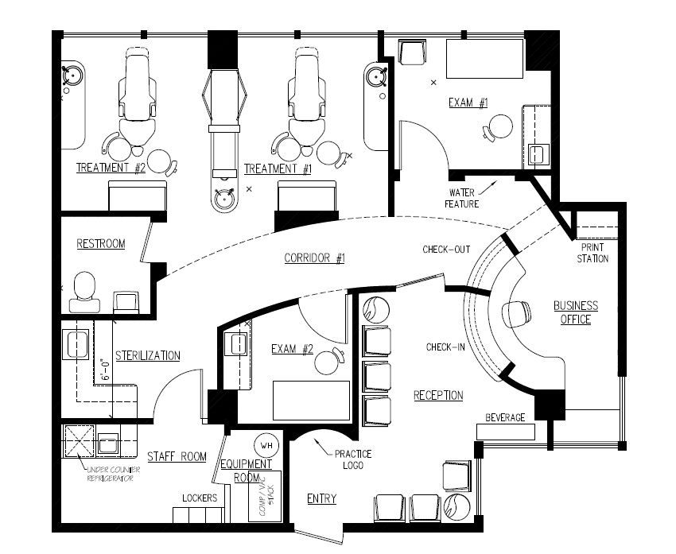
Figure 1: floor plan
Job description of spa personnel
Hair stylists in the salon section will be required to wash, treat, and style clients based on their needs. Employees in the spa section will be required to provide body treatments, waxing, facials, manicure and pedicure, and massages. Employees in both sections will be required to clean and maintain equipment and inventory.

